MCG Commercial Access Guidelines – Filming, Photography and Publicity Events

Introduction
The Melbourne Cricket Ground (MCG) is an internationally recognised venue and brand that also holds National Heritage Listing status.

It is the Melbourne Cricket Club’s (MCC) responsibility to preserve the integrity of the stadium and control the use of MCG, MCC and Australian Sports Museum (ASM) intellectual property rights, including but not limited to all present and future rights (whether registered or unregistered) conferred by law in or in relation to: patents, copyright, trademarks, designs, circuit layouts, plant varieties, business and domain names, know how, trade secrets, brands and any images created that depict or represent the MCG or parts of the MCG, or are taken of the MCG or parts of the MCG (“MCG IP”).

The MCC abides by Film Victoria’s film friendly principles and will work to facilitate on-site filming requests where it can, provided these requests do not interfere with our sponsorship agreements, commercial revenues or day-to-day operations.

Applicants must understand that the MCG operates as a venue 365 days per year. Venue hirers such as sporting bodies and conference organisers expect and pay for standards of access and in some cases, privacy or exclusivity. MCG ground staff are also working on arena maintenance and it is the MCC’s primary responsibility to present the arena in premium and safe conditions for players therefore arena works will take precedent over filming.

All requests to film, take photos or conduct publicity events at the MCG must gain prior approval from the MCC.

All applications must be made by submitting the application form to the MCC at least two weeks prior to the requested activity date. This allows enough time to review the application and make necessary arrangements.

This document outlines the MCG fee schedule and guidelines for commercial access at the MCG.

Fee Schedule
The MCG is a highly sought after location where a wide range of operational activity occurs every day of the year. Please find below the various fees that will apply if your application is approved. The total fees will be calculated as follows:
MCC Resource Fee | $
Venue Access Fee | $
Commercial Licensing Fee | $
Cost Recovery Fee | $
Total Fee | $

MCC Resource Fee
Application and Assessment Fee | 0-3 hours | 3-6 hours | 6-10 hours | >10 hours
 | $300 | $600 | $1000 | Price on application

On-site meeting | $150/hr during business hours (Mon to Fri 9am – 5pm)  $300/hr outside of business hours

MCC staff member supervision fees | $150/hr during business hours (Mon to Fri 9am – 5pm)  $300/hr outside of business hours

Venue Access Fee
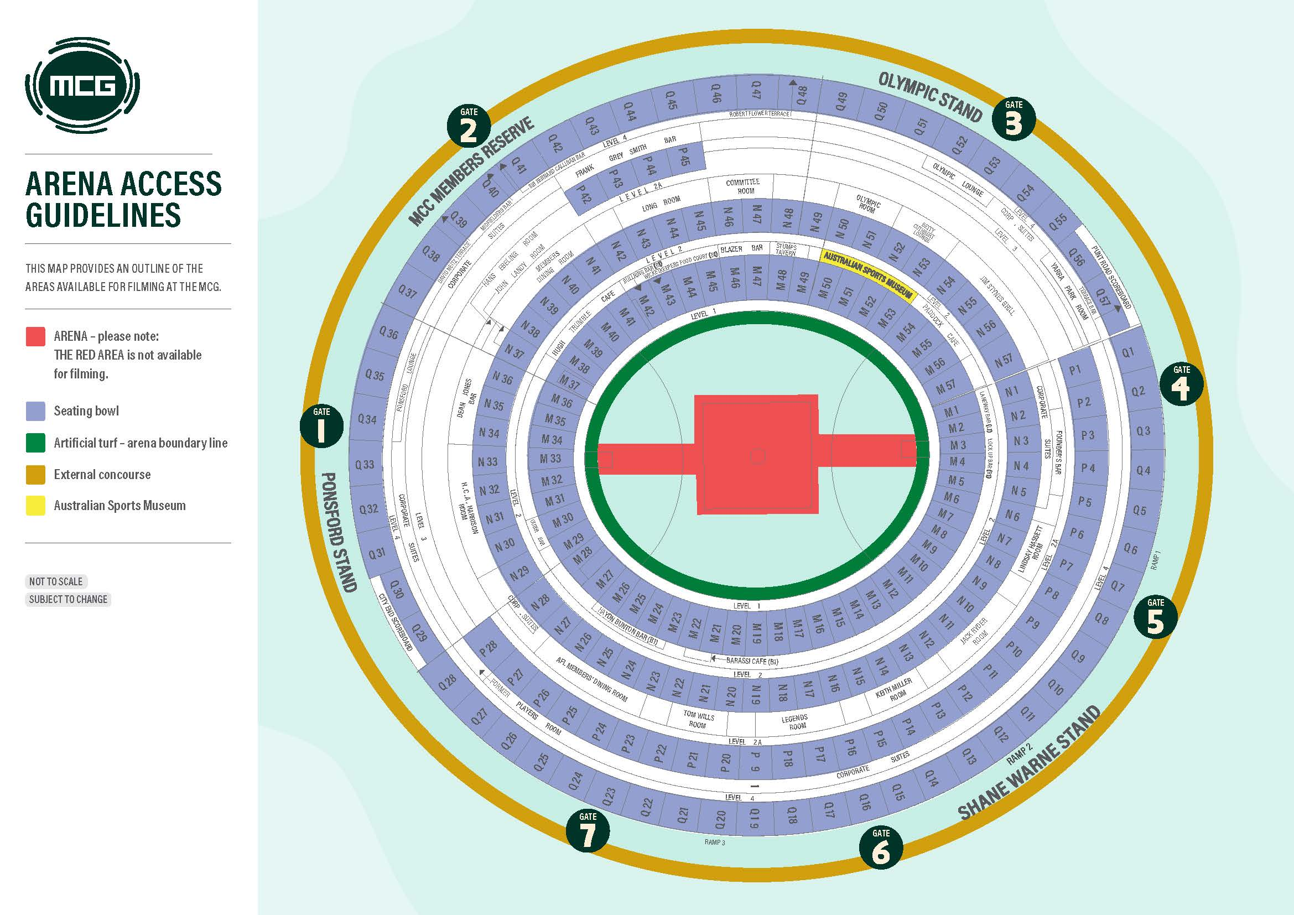

Location | Full day venue hire fee  7-9 hours  (including bump in and bump out time)  Additional Hourly hire fee applies for filming exceeding 9 hours. | Half day venue hire fee  4-7 hours  (including bump in and bump out time) | Hourly hire fee  (including bump in and bump out time)
- Arena (not accessible: centre square, centre corridor and goal squares) | $25,000 per day | $15,000 per half-day | $5,000 per hour
- Artificial turf (arena boundary)  - Seating bowl  - Player change rooms and race  - Corporate suites/corporate corridors/function rooms  - External concourse  - Other (please provide details in the blank area below) | $7,500 per day | $4,375 per half-day | $1,500 per hour
- Australian Sports Museum | $3,750 per day | $2,250 per half day | $750 per hour
- Yarra Park  (Fees will increase dependent on infrastructure brought on site and the lawn/s selected for filming.) | Minimum $1,750 per day | Minimum $1249 per  half day | Minimum $992 per hour
* All fees are excluding GST

Commercial Licensing Fee
Where any production involves the capturing of images where the MCG is in any way recognisable or includes any audible or visual reference to the MCG, MCC or ASM, the commercial licensing fee applies.

The commercial licensing fee will be charged at the discretion of the MCC’s Commercial Operations department, and will be assessed on a case-by-case basis, based on the information provided in the application form. The Commercial Licensing Fee starts from $5,000 +GST.

The commercial licensing fee will be determined by a rating scale based on the extent to which MCG IP is exploited. Applicants will be informed of the applicable commercial licensing fee in response to the application.

Please note: Payment of the commercial licensing fee does not grant permission for the company to imply a direct association with the MCG, MCC or ASM.

Cost Recovery Fee
MCC support personnel may be required depending on the nature and scale of the production. Please note that charge rates will change periodically, and that higher rates apply on weekends and Public Holidays. Minimum call times may apply.

The MCC will advise of support personnel required and what fees would apply. Support personnel could include:
- MCG Audio Visual Staff & Electricians (staging/lighting/audio crew, installation of additional power)
- MCG Security Officer
- MCG Event Office
- MCG Cleaning
- Yarra Park car parking operator

Guidelines for filming at the MCG
Lodging the Application
All requests to film, take photos or conduct publicity events at the MCG must gain prior approval from the MCC.

All applications must be made by completing the online form at https://mcg.org.au/about-us/media/filming-photography-and-publicity-event-requests at least two weeks prior to the requested activity date. This allows enough time to review the application and make necessary arrangements.

The MCC will respond to your application within five business days of receiving it. Please note if the MCC need to make complex arrangements for your filming activity it may take more than five days to approve your application.

If your application is approved we will send a venue access agreement including details of terms and conditions that apply and any associated fees.

If a request is denied a clear rationale will be provided for doing so.

Venue Access Agreement
Approved applicants will be required to complete and sign a venue access agreement, which will be provided by the MCC.

If your application is approved you will also be required to provide a list of those attending, and vehicle requirements.

You may also be required to provide a run sheet and risk management plan.
Public Liability Insurance
Approved applicants will be required to provide a copy of the production company’s public liability insurance to the value of $20,000,000, along with the MCG being cited as a place where the venue hirer’s insurance is valid.

Occupational Health and Safety
Compliance with strict site safety requirements is imperative to protect all our staff and visitors. The approved applicant is responsible for the safety of their employees and contractors, and must ensure that their activities comply with all relevant legislation and do not create a hazardous environment for anyone visiting or working at the MCG.
Online Induction Training
All crew and talent must complete the online occupational health and safety induction training in advance of filming at the MCG. The training is valid for two years.
Should the client be unable to complete safety training for any reason, they will still be able to proceed with the shoot. However, they must be accompanied at all times while on site by a staff member and therefore labour fees will apply.
Equipment
All equipment brought into the venue must be tagged and tested to comply with MCG safety requirements.

Catering
No external catering may be brought onsite. Any catering for film crews must be arranged through our catering partner Epicure at least 4 days prior to the filming date. For smaller film shoots, the Hugh Trumble Café is available for breakfast, lunch and refreshments from 7.30am to 2pm. The Paddock Café is also available for breakfast, lunch and refreshments from 8.30am through 4pm. Further information available upon request.
Location
When filming is over, the crew must leave the area in a clean and tidy condition. If the location has been changed or damaged in any way, the applicant is responsible for restoring the area to its original condition and paying for any repairs.

Non compliance with venue access agreement
When conditions of a venue access agreement have been breached, the following actions may be taken:
- Cancellation of any approval that has been issued for the day in question.
- Instruction to cease all activities immediately and remove all personnel and equipment from the site.
- Forfeit of any and all fees paid to MCC to offset any losses or damages incurred.
- Additional fees may be incurred to offset any losses, damages or reinstatement costs.

Cancellation
Should the applicant change its mind and cancel the booking after its application has been provisionally approved, the applicant will be liable for the payment of the administration fees plus any other costs incurred by the MCC in preparation for the production.
A booking may be cancelled by the MCC at its discretion due to circumstances including but not limited to such as the weather or non-availability of the MCG. If the MCC cancels the booking, the administration, venue access and commercial licensing fees will be fully refundable. Only hard costs incurred by the MCC will need to be recovered from the applicant.

Non-match day filming – Australian Sports Museum
Terms of Access
Access to film within the Australian Sports Museum (ASM) is conditional upon the user agreeing with the following terms and conditions, in addition to the guidelines specified in the preceding document:

- Only general views of the ASM galleries, exhibitions and spaces may be filmed and no close up photography or filming of individual objects is permitted. The ASM is not the owner of all intellectual property contained within the ASM and third parties (lenders of objects, artists whose work is displayed, etc.) should be contacted by the user if third party intellectual property is to be photographed or filmed.
- No adjustments to the ASM’s audio-visual systems will be made by the ASM during public opening hours.
- Users must not attempt to alter, modify or manipulate and video or audio signal, images or data within the ASM in any way.
- ASM display lighting cannot be adjusted at any time. Users are requested to bring their own temporary lighting if it is required.
- All equipment brought into the venue must be tagged and tested to comply with MCG safety requirements.
- Filming in the ASM during public opening hours (10am-5pm, seven days a week) will only be approved under special circumstances.
- If filming during public opening times, the user must not:
    - adversely affect the experience of ASM patrons
    - leave equipment unattended
    - run unsecured cables across walkways
- No food or drink may be brought into the ASM under any circumstances.

The user acknowledges that the Melbourne Cricket Club has the right to control access to the ASM and may arrange for the removal of any person who fails to comply with these terms.
It is strongly recommended that all potential users visit the ASM in advance of filming to discuss power and logistical requirements with the ASM. Failure to do this may result in requirements not being able to be met.
Access requests for filming in ASM will be considered in relation to other activities such as functions, gallery maintenance and exhibition installation.

